ЛАБОРАТОРНА РОБОТА № 4

Тема: Поведінкові шаблони

Мета: навчитися реалізовувати структурні шаблони проєктування а саме Ланцюжок відповідальностей, Посередник, Спостерігач, Стратегія та Мементо

Хід роботи:

Завдання 1:
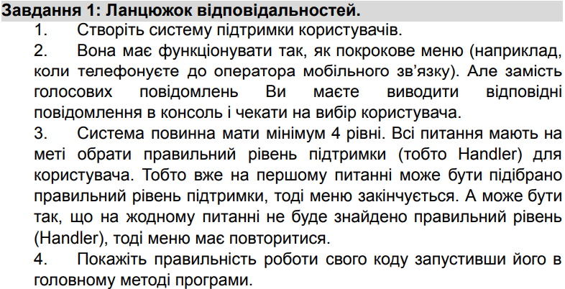
Program.cs:
using ChainOfResponsibility;

class Program
{
static void Main()
{
var menu = new SupportMenu();
menu.Start();
}
}
Handlers/SupportHandler.cs:
using System;
using System.Collections.Generic;
using System.Linq;
using System.Text;
using System.Threading.Tasks;

namespace ChainOfResponsibility.Handlers
{
public abstract class SupportHandler
{
protected SupportHandler? NextHandler;

public void SetNext(SupportHandler next)
{
NextHandler = next;
}

public abstract bool Handle(SupportRequest request);
}
}

Handlers/Level1Support.cs:
using System;
using System.Collections.Generic;
using System.Linq;
using System.Text;
using System.Threading.Tasks;

namespace ChainOfResponsibility.Handlers
{
public class Level1Support : SupportHandler
{
public override bool Handle(SupportRequest request)
{
if (request.IssueType == "1")
{
Console.WriteLine("Level 1 Support: Handled the issue.");
return true;
}
return NextHandler?.Handle(request) ?? false;
}
}
}

Handlers/Level2Support.cs:
using System;
using System.Collections.Generic;
using System.Linq;
using System.Text;
using System.Threading.Tasks;

namespace ChainOfResponsibility.Handlers
{
public class Level2Support : SupportHandler
{
public override bool Handle(SupportRequest request)
{
if (request.IssueType == "2")
{
Console.WriteLine("Level 2 Support: Handled the issue.");
return true;
}
return NextHandler?.Handle(request) ?? false;
}
}
}

Handlers/Level3Support.cs:
using System;
using System.Collections.Generic;
using System.Linq;
using System.Text;
using System.Threading.Tasks;

namespace ChainOfResponsibility.Handlers
{
public class Level3Support : SupportHandler
{
public override bool Handle(SupportRequest request)
{
if (request.IssueType == "3")
{
Console.WriteLine("Level 3 Support: Handled the issue.");
return true;
}
return NextHandler?.Handle(request) ?? false;
}
}
}

Handlers/DefaultSupport.cs:
using System;
using System.Collections.Generic;
using System.Linq;
using System.Text;
using System.Threading.Tasks;

namespace ChainOfResponsibility.Handlers
{
public class DefaultSupport : SupportHandler
{
public override bool Handle(SupportRequest request)
{
Console.WriteLine("Sorry, your issue could not be resolved. Please try again.");
return false;
}
}
}

SupportMenu.cs:
using System;
using System.Collections.Generic;
using System.Linq;
using System.Text;
using System.Threading.Tasks;
using ChainOfResponsibility.Handlers;

namespace ChainOfResponsibility
{
public class SupportMenu
{
private readonly SupportHandler _handlerChain;

public SupportMenu()
{
var level1 = new Level1Support();
var level2 = new Level2Support();
var level3 = new Level3Support();
var defaultHandler = new DefaultSupport();

level1.SetNext(level2);
level2.SetNext(level3);
level3.SetNext(defaultHandler);

_handlerChain = level1;
}

public void Start()
{
bool handled = false;

while (!handled)
{
Console.WriteLine("Welcome to Support System!");
Console.WriteLine("Select your issue:");
Console.WriteLine("1 - Password Reset");
Console.WriteLine("2 - Payment Issue");
Console.WriteLine("3 - Technical Problem");
Console.WriteLine("Any other key - Unknown Issue");

string input = Console.ReadLine() ?? "";
var request = new SupportRequest(input);

handled = _handlerChain.Handle(request);
if (!handled)
{
Console.WriteLine("Restarting menu...\n");
}
}
}
}
}

SupportRequest.cs:
using System;
using System.Collections.Generic;
using System.Linq;
using System.Text;
using System.Threading.Tasks;

namespace ChainOfResponsibility
{
public class SupportRequest
{
public string IssueType { get; set; }

public SupportRequest(string issueType)
{
IssueType = issueType;
}
}
}
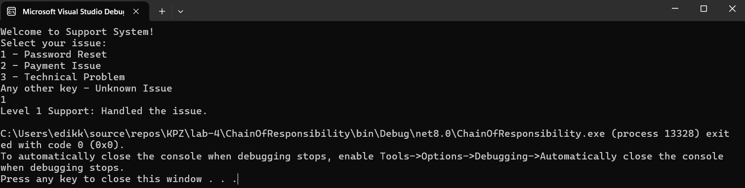
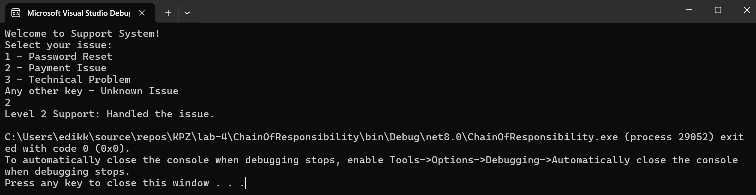
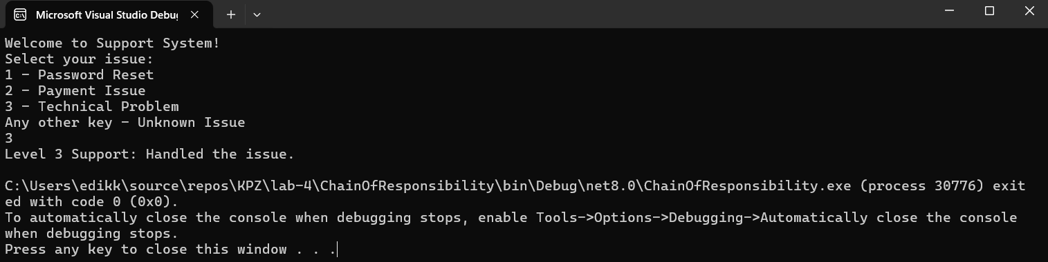
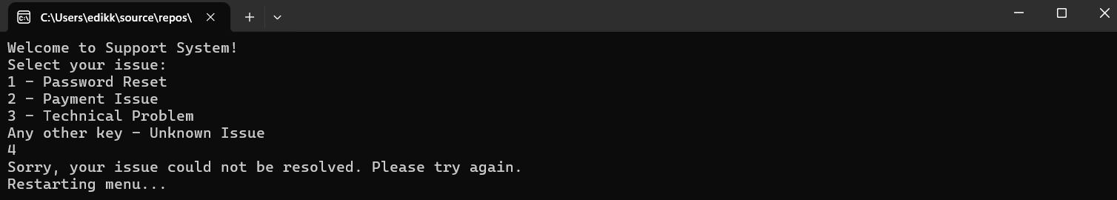
Рис. 1 – 4 Результат виконання завдання
Завдання 2:
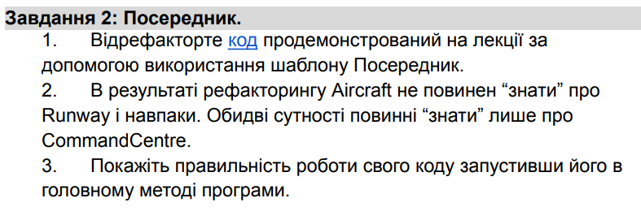
Program.cs:
using Mediator;

class Program
{
static void Main()
{
var runway1 = new Runway();
var runway2 = new Runway();

var commandCentre = new CommandCentre(new[] { runway1, runway2 });

var aircraft1 = new Aircraft("Boeing-737", commandCentre);
var aircraft2 = new Aircraft("Airbus-A320", commandCentre);

aircraft1.RequestLanding();
aircraft2.RequestLanding();

aircraft1.RequestTakeOff();
aircraft2.RequestTakeOff();

aircraft2.RequestLanding();
}
}
Aircraft.cs:
using Mediator;
using System;
using System.Collections.Generic;
using System.Linq;
using System.Text;
using System.Threading.Tasks;

namespace Mediator
{
class Aircraft
{
public string Name { get; }
public bool IsTakingOff { get; set; }

private CommandCentre _commandCentre;

public Aircraft(string name, CommandCentre commandCentre)
{
Name = name;
_commandCentre = commandCentre;
}

public void RequestLanding()
{
_commandCentre.RequestLanding(this);
}

public void RequestTakeOff()
{
_commandCentre.RequestTakeOff(this);
}
}
}

Runaway.cs:
using System;
using System.Collections.Generic;
using System.Linq;
using System.Text;
using System.Threading.Tasks;

namespace Mediator
{
class Runway
{
public readonly Guid Id = Guid.NewGuid();
public Aircraft? OccupiedBy { get; private set; }

public bool IsFree => OccupiedBy == null;

public void Occupy(Aircraft aircraft)
{
OccupiedBy = aircraft;
Console.WriteLine($"Runway {Id} is now occupied by aircraft {aircraft.Name}.");
HighlightRed();
}

public void Release()
{
Console.WriteLine($"Runway {Id} is now free.");
OccupiedBy = null;
HighlightGreen();
}

public void HighlightRed()
{
Console.WriteLine($"Runway {Id} is busy!");
}

public void HighlightGreen()
{
Console.WriteLine($"Runway {Id} is free!");
}
}
}

CommandCentre.cs:
using System;
using System.Collections.Generic;
using System.Linq;
using System.Text;
using System.Threading.Tasks;

namespace Mediator
{
class CommandCentre
{
private List<Runway> _runways = new();

public CommandCentre(IEnumerable<Runway> runways)
{
_runways.AddRange(runways);
}

public void RequestLanding(Aircraft aircraft)
{
Console.WriteLine($"Aircraft {aircraft.Name} is requesting landing...");

var availableRunway = _runways.FirstOrDefault(r => r.IsFree);
if (availableRunway != null)
{
Console.WriteLine($"Aircraft {aircraft.Name} is landing on runway {availableRunway.Id}.");
availableRunway.Occupy(aircraft);
}
else
{
Console.WriteLine("No free runways. Landing denied.");
}
}

public void RequestTakeOff(Aircraft aircraft)
{
Console.WriteLine($"Aircraft {aircraft.Name} is requesting take-off...");

var runway = _runways.FirstOrDefault(r => r.OccupiedBy == aircraft);
if (runway != null)
{
Console.WriteLine($"Aircraft {aircraft.Name} is taking off from runway {runway.Id}.");
runway.Release();
}
else
{
Console.WriteLine($"Aircraft {aircraft.Name} is not on any runway.");
}
}
}
}
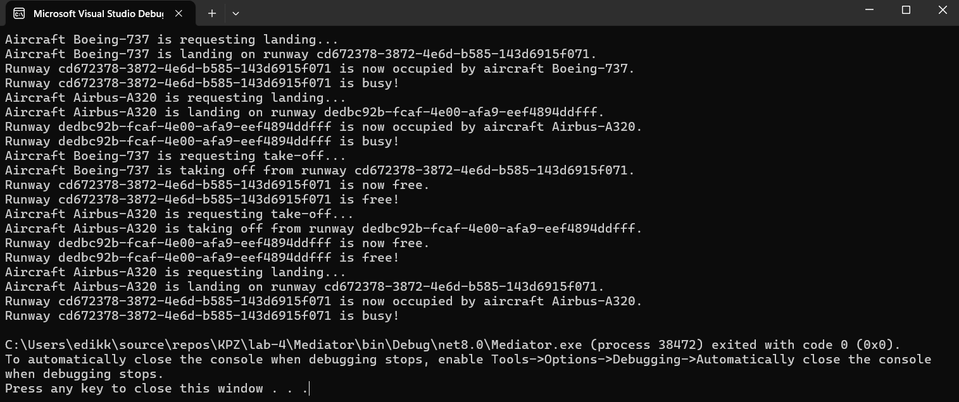
Рис. 5 Результат виконання завдання

Завдання 3:
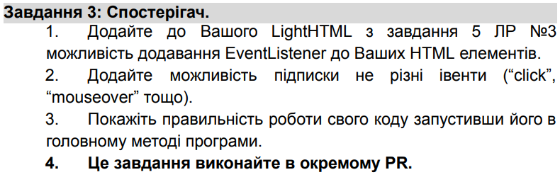
Program.cs:
using Observer;
using System;

namespace ObserverPattern
{
class Program
{
static void Main(string[] args)
{
var div = new LightElementNode("div", DisplayType.Block, ClosingType.Double);
var paragraph = new LightElementNode("p", DisplayType.Block, ClosingType.Double);
paragraph.AddChild(new LightTextNode("Hello, world!"));

div.AddEventListener("click", new ClickListener("Div"));
paragraph.AddEventListener("click", new ClickListener("Paragraph"));

div.TriggerEvent("click");
paragraph.TriggerEvent("click");
}
} }
IEventListener.cs:
using System;
using System.Collections.Generic;
using System.Linq;
using System.Text;
using System.Threading.Tasks;

namespace Observer
{
public interface IEventListener
{
void HandleEvent(string eventType);
}
}

ClickListener.cs:
using System;
using System.Collections.Generic;
using System.Linq;
using System.Text;
using System.Threading.Tasks;

namespace Observer
{
public class ClickListener : IEventListener
{
private readonly string _name;

public ClickListener(string name)
{
_name = name;
}

public void HandleEvent(string eventType)
{
Console.WriteLine($"{_name} clicked!");
}
}
}

LightNode.cs:
using System;
using System.Collections.Generic;
using System.Linq;
using System.Text;
using System.Threading.Tasks;

namespace Observer
{
public abstract class LightNode
{
public abstract string OuterHTML { get; }
public abstract string InnerHTML { get; }
}
}
LightTextNode.cs:
using System;
using System.Collections.Generic;
using System.Linq;
using System.Text;
using System.Threading.Tasks;

namespace Observer
{
public class LightTextNode : LightNode
{
private string _text;

public LightTextNode(string text)
{
_text = text;
}

public override string OuterHTML => _text;
public override string InnerHTML => _text;
}
}

LightElementNode.cs:
using System;
using System.Collections.Generic;
using System.Linq;
using System.Text;
using System.Threading.Tasks;

namespace Observer

{
public enum DisplayType { Block, Inline }
public enum ClosingType { Single, Double }

public class LightElementNode : LightNode
{
public string TagName { get; }
public DisplayType Display { get; }
public ClosingType Closing { get; }
public List<string> CssClasses { get; } = new();
public List<LightNode> Children { get; } = new();

private readonly Dictionary<string, List<IEventListener>> _eventListeners = new();

public LightElementNode(string tagName, DisplayType display, ClosingType closing)
{
TagName = tagName;
Display = display;
Closing = closing;
}

public void AddClass(string className) => CssClasses.Add(className);
public void AddChild(LightNode node) => Children.Add(node);

public override string InnerHTML => string.Join("", Children.Select(c => c.OuterHTML));

public override string OuterHTML
{
get
{
string classes = CssClasses.Count > 0 ? $" class=\"{string.Join(" ", CssClasses)}\"" : "";
if (Closing == ClosingType.Single)
return $"<{TagName}{classes} />";
else
return $"<{TagName}{classes}>{InnerHTML}</{TagName}>";
}
}

public void AddEventListener(string eventType, IEventListener listener)
{
if (!_eventListeners.ContainsKey(eventType))
{
_eventListeners[eventType] = new List<IEventListener>();
}
_eventListeners[eventType].Add(listener);
}

public void TriggerEvent(string eventType)
{
if (_eventListeners.ContainsKey(eventType))
{
foreach (var listener in _eventListeners[eventType])
{
listener.HandleEvent(eventType);
}
}
}
}
}
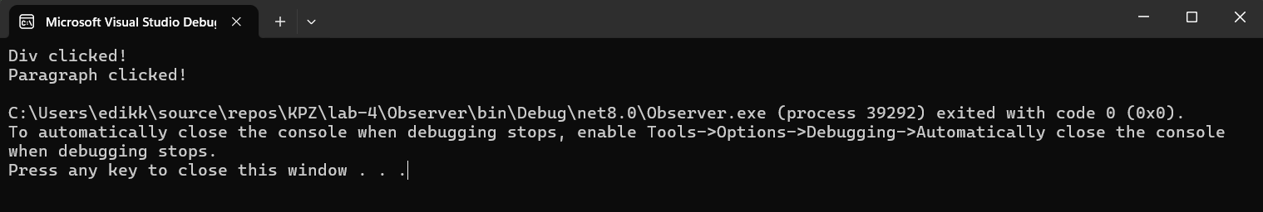
Рис. 6 Результат виконнаня завдання

Завдання 4:
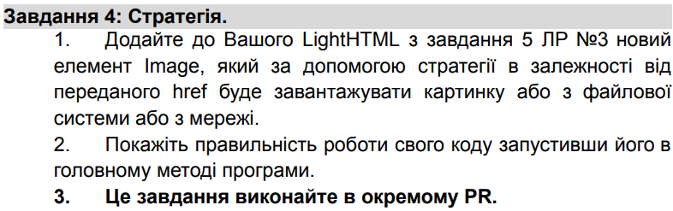
Program.cs:
using Strategy;
using System;

namespace StrategyPattern
{
class Program
{
static void Main(string[] args)
{
var fileLoadStrategy = new FileLoadStrategy();
var networkLoadStrategy = new NetworkLoadStrategy();

var imageElement = new ImageElementNode("img", DisplayType.Block, ClosingType.Single, fileLoadStrategy);
Console.WriteLine(imageElement.LoadImage("image.jpg"));

imageElement.SetLoadStrategy(networkLoadStrategy);
Console.WriteLine(imageElement.LoadImage("http://example.com/image.jpg"));
}
}
}

FileLoadStrategy.cs:
using System;
using System.Collections.Generic;
using System.Linq;
using System.Text;
using System.Threading.Tasks;

namespace Strategy
{
public class FileLoadStrategy : ILoadStrategy
{
public string Load(string source)
{
return $"Loading image from file: {source}";
}
}
}

NetworkLoadStrategy.cs:
using System;
using System.Collections.Generic;
using System.Linq;
using System.Text;
using System.Threading.Tasks;

namespace Strategy
{
public class NetworkLoadStrategy : ILoadStrategy
{
public string Load(string source)
{
return $"Loading image from network: {source}";
}
}
}
ILoadStrategy.cs:
using System;
using System.Collections.Generic;
using System.Linq;
using System.Text;
using System.Threading.Tasks;

namespace Strategy
{
public interface ILoadStrategy
{
string Load(string source);
}
}

ImageElementNode.cs:
using System;
using System.Collections.Generic;
using System.Linq;
using System.Text;
using System.Threading.Tasks;

namespace Strategy
{
public class ImageElementNode : LightElementNode
{
private ILoadStrategy _loadStrategy;

public ImageElementNode(string tagName, DisplayType display, ClosingType closing, ILoadStrategy loadStrategy)
: base(tagName, display, closing)
{
_loadStrategy = loadStrategy;
}

public void SetLoadStrategy(ILoadStrategy newStrategy)
{
_loadStrategy = newStrategy;
}

public string LoadImage(string source)
{
return _loadStrategy.Load(source);
}
}
}

LightElementNode.cs:
using System;
using System.Collections.Generic;
using System.Linq;
using System.Text;
using System.Threading.Tasks;

namespace Strategy
{
public enum DisplayType { Block, Inline }
public enum ClosingType { Single, Double }

public class LightElementNode : LightNode
{
public string TagName { get; }
public DisplayType Display { get; }
public ClosingType Closing { get; }
public List<string> CssClasses { get; } = new();
public List<LightNode> Children { get; } = new();

public LightElementNode(string tagName, DisplayType display, ClosingType closing)
{
TagName = tagName;
Display = display;
Closing = closing;
}

public void AddClass(string className) => CssClasses.Add(className);
public void AddChild(LightNode node) => Children.Add(node);

public override string InnerHTML => string.Join("", Children.Select(c => c.OuterHTML));

public override string OuterHTML
{
get
{
string classes = CssClasses.Count > 0 ? $" class=\"{string.Join(" ", CssClasses)}\"" : "";
if (Closing == ClosingType.Single)
return $"<{TagName}{classes} />";
else
return $"<{TagName}{classes}>{InnerHTML}</{TagName}>";
}
}
}
}

LightNode.cs:
using System;
using System.Collections.Generic;
using System.Linq;
using System.Text;
using System.Threading.Tasks;

namespace Strategy
{
public abstract class LightNode
{
public abstract string OuterHTML { get; }
public abstract string InnerHTML { get; }
}
}
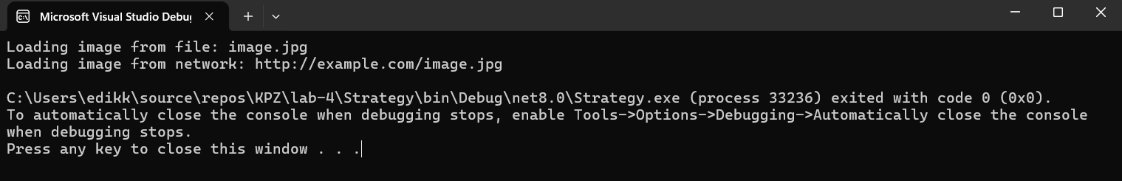
Рис. 7 Результат виконання завдання
Завдання 5:
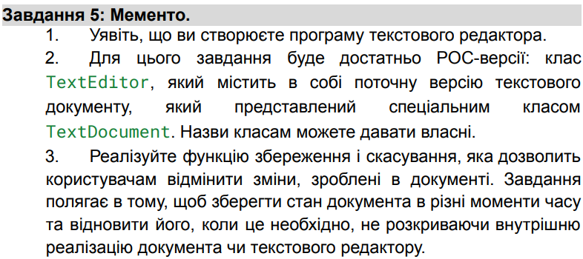
Program.cs:
using Memento;
using System;

namespace Memento
{
class Program
{
static void Main(string[] args)
{
var editor = new TextEditor();
editor.AddText("Hello, world!");
Console.WriteLine(editor.GetText());

editor.Save();

editor.AddText(" How are you?");
Console.WriteLine(editor.GetText());

editor.Undo();
Console.WriteLine(editor.GetText());
}
}
}

TextEditor.cs:
using System;
using System.Collections.Generic;
using System.Linq;
using System.Text;
using System.Threading.Tasks;

namespace Memento
{
public class TextEditor
{
private TextDocument _document = new TextDocument();
private Caretaker _caretaker = new Caretaker();

public void AddText(string text)
{
_document.Text += text;
}

public string GetText()
{
return _document.Text;
}

public void Save()
{
_caretaker.SaveState(_document.CreateMemento());
}

public void Undo()
{
var memento = _caretaker.RestoreState();
if (memento != null)
{
_document.RestoreMemento(memento);
}
}
}
}

TextDocument.cs:
using System;
using System.Collections.Generic;
using System.Linq;
using System.Text;
using System.Threading.Tasks;

namespace Memento
{
public class TextDocument
{
public string Text { get; set; } = string.Empty;

public Memento CreateMemento()
{
return new Memento(Text);
}

public void RestoreMemento(Memento memento)
{
Text = memento.Text;
}
}
}

Memento.cs:
using System;
using System.Collections.Generic;
using System.Linq;
using System.Text;
using System.Threading.Tasks;

namespace Memento
{
public class Memento
{
public string Text { get; private set; }
public Memento(string text)
{
Text = text;
}
}
}

Caretaker.cs:
using System;
using System.Collections.Generic;
using System.Linq;
using System.Text;
using System.Threading.Tasks;

namespace Memento
{
public class Caretaker
{
private Memento _memento;

public void SaveState(Memento memento)
{
_memento = memento;
}

public Memento RestoreState()
{
return _memento;
}
}
}

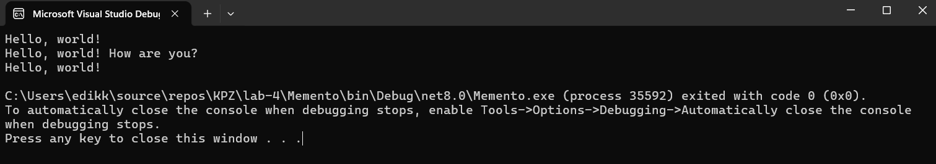
Рис. 8 Результат виконання завдання

Висновки: я навчився реалізовувати структурні шаблони проєктування а саме Ланцюжок відповідальностей, Посередник, Спостерігач, Стратегія та Мементо

